**Bahria University,**

**Karachi Campus**



**LAB EXPERIMENT NO.**

**_11**

**LIST OF TASKS**

|  |  |
| --- | --- |
| TASK NO | **OBJECTIVE** |
| 01 | Deploy a simple blog website on Internet Information Services (IIS) for hosting. |
| 02 | Develop a web application using ASP.NET Core that enables CRUD (Create, Read, Update, and Delete) operations for managing employee records. Deploy the application on Internet Information Services (IIS) for hosting. |

**Submitted On:**

**Date: 16/May/2024**

**TASK 1:**Deploy a simple blog website on Internet Information Services (IIS) for hosting.

**Model:**

public class Post

{

public int Id { get; set; }

public string Title { get; set; }

public string Content { get; set; }

public string Author { get; set; }

public string Email { get; set; }

public DateTime PublishedDate { get; set; }

}

**Controller:**

public class BlogController : Controller

{

private readonly IPostRepository _postRepository;

public BlogController(IPostRepository postRepository)

{

_postRepository = postRepository;

}

public IActionResult Create()

{

return View();

}

[HttpPost]

public IActionResult Create(Post post)

{

if (ModelState.IsValid)

{

post.PublishedDate = DateTime.Now;

_postRepository.Save(post);

return RedirectToAction("Index", "Home"); // Assuming HomeController and Index action for home page

}

return View(post);

}

}**VIEW:**

<!DOCTYPE html>

<html lang="en">

<head>

<meta charset="UTF-8">

<meta name="viewport" content="width=device-width, initial-scale=1.0">

<title>Create a New Post</title>

<link rel="stylesheet" href="~/Content/style.css"> </head>

<body>

<h1>Create a New Post</h1>

<form method="post">

<div class="form-group">

<label for="title">Title:</label>

<input type="text" id="title" name="title" required>

</div>

<div class="form-group">

<label for="content">Content:</label>

<textarea id="content" name="content" required></textarea>

</div>

<div class="form-group">

<label for="author">Author:</label>

<input type="text" id="author" name="author" required>

</div>

<div class="form-group">

<label for="email">Email:</label>

<input type="email" id="email" name="email" required>

</div>

<button type="submit">Submit Post</button>

</form>

</body>

</html>

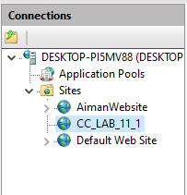 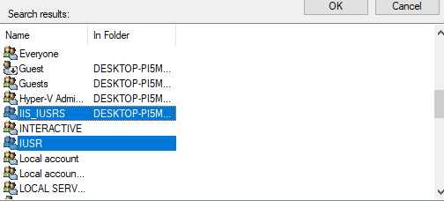

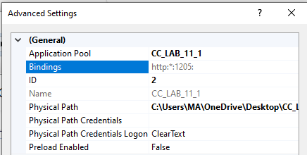

**TASK 2:**Develop a web application using ASP.NET Core that enables CRUD (Create, Read, Update, and Delete) operations for managing employee records. Deploy the application on Internet Information Services (IIS) for hosting.

public class Employee

{

public int Id { get; set; }

public string Name { get; set; }

public string Email { get; set; }

}

public class EmployeeController : Controller

{

private readonly YourDbContext _context;

public EmployeeController(YourDbContext context)

{

_context = context;

}

public IActionResult Index()

{

var employees = _context.Employees.ToList();

return View(employees);

}

public IActionResult Create()

{

return View();

}

[HttpPost]

public IActionResult Create(Employee employee)

{

if (ModelState.IsValid)

{

_context.Employees.Add(employee);

_context.SaveChanges();

return RedirectToAction(nameof(Index));

}

return View(employee);

} }

@model List<Employee>

<table>

<thead>

<tr>

<th>@Html.DisplayNameFor(model => model.Id)</th>

<th>@Html.DisplayNameFor(model => model.Name)</th>

<th>@Html.DisplayNameFor(model => model.Email)</th>

<th></th>

</tr>

</thead>

<tbody>

@foreach (var item in Model)

{

<tr>

<td>@item.Id</td>

<td>@item.Name</td>

<td>@item.Email</td>

<td>

@Html.ActionLink("Edit", "Edit", new { id = item.Id }) |

@Html.ActionLink("Delete", "Delete", new { id = item.Id }, new { @class = "text-danger" })

</td>

</tr>

}

</tbody>

</table>



